Purchase requisition to Purchase order Automation using Fiori App in BTP Platform - Version 01

Table of Contents
Table of Contents 1
1 Introduction 2
2 PR to PO conversion 2
3 PR to PO Process Flow 2
3.1 Extract PRs: 3
3.2 Validate prerequisites for PRs and Display the log: 3
3.3 Review, Validate, Re Organize list of PRs: 4
3.4 Corrective actions based on the error log: 4
3.5 Selection of PRs and consolidate multiple PRs to release:( Execute PO conversion) 4
3.6 View Status of converted PO: 5
4 Purchase Order Communication to External Vendor and MRP controller 5
5 PO Header Text Field instruction 5
6 Not in Scope 5
7 Application Functionality 6
7.1 Extract PRs, Review, Edit and Convert: Dashboard 1 6
8 Acronyms 7

Introduction

This is to define the scope of the new process to convert purchase requisition to Purchase order by MRP controllers.

PR to PO conversion
Phase1:
Purchase requisitions originated from IBP are planned to convert into Purchase order, Purchase requisition will be reviewed and released by MRP controller. This conversion has the following functionalities to fulfill business requirements.
Phase 2: Once the system is stabilized, automatic functionality of PO conversion will be enabled.

PR to PO Process Flow

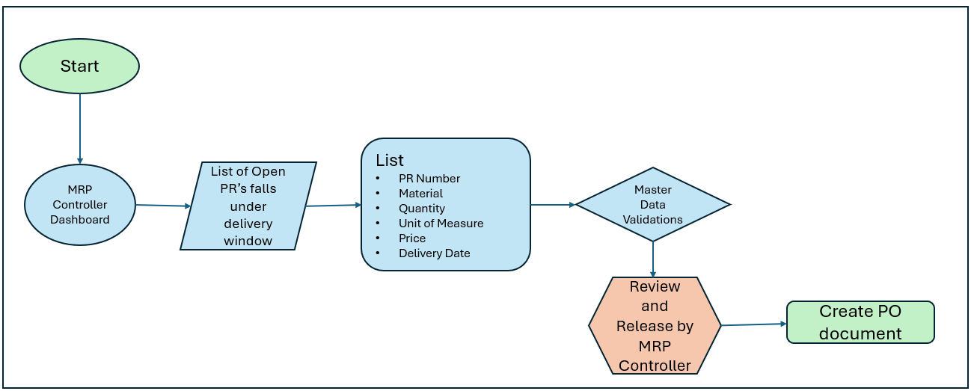

Process Steps:

ID | Process Step | Responsible (Local Operations to complete)
1 | Extract PR | Application
2 | Validate prerequisites for PRs and Display the log | Application
3 | Review, Validation list of PRs | MRP controller
4 | Corrective actions based on the error log | MRP controller
5 | Selection of PRs and consolidating multiple PRs to release (Execute PO conversion)  Option1: Single PR to Single PO  Option2: Multiple PRs to Single PO | MRP controller
6 | View Status of converted PO:  - Status of PO output to vendor and MRP controller via E Mail. PO output type: ZEML / NEU based on existing Output type maintained for Purchase order. No change in the Existing PO Output.  - GRN status - Per PO line item | MRP controller can view status of all the converted POs.

Extract PRs:

Extraction of the PRs will be based on the following parameters
- PR release Date - Current date plus 4 weeks and minus 1 week (workday)
- Filter option required to select a responsible MRP controller from extracted list of PRs
  - PRs will display based on the login MRP controller
  - Other PRs can be displayed, after plant and MRP controller input
- PRs originated from IBP (Created by the user IBP*)
- Document type NB
- Must have Material number
- PRs assigned Only for external vendor
- PR Item category 0 – Standard PR
- PR Account Assignment category – Blank
- PR creation indicator – A – SAP APO
- PR closed status – Should be blank (It will exclude closed PRs)
- PO created by will be the specific system user ID BTPPUR

Validate prerequisites for PRs and Display the log:

Validations for the listed PRs are based on the following parameters
- Check the PR has been created with assigned source (fixed Vendor)
- Check Auto PO activated at Material Master Data
- Check Auto PO activated at Vendor Master Data
- Check the Material has Valid Source list with Fixed vendor and MRP relevant.
- Purchasing info record/ Contract with current validity period and valid Price.
Provide log if any one of the above parameters are missed in the specific PR line
Unit and UAT testing with different scenarios aligned with business:
Scenario 1 : Only one vendor is Valid in Source List with MRP Indicator 1, IBP creates purchase requisition by using it.
Scenario 2 : Only one vendor is Valid in Source List with Fixed Indicator, IBP creates purchase requisition by using it.
Scenario 3 : Multiple vendors, Fix indicator considered as highest priority.
Scenario 4 : Multiple vendors, with no Fix indicator and MRP are maintained will consider.
Scenario 5 : NO vendor is valid and therefore Do Not Integrate any info record for this Material and Plant. IBP cannot create purchase requisition.
Scenario 6 : Multiple vendors marked as MRP for same product. This scenario requires Quota setup in SAP ECC to work properly.
Our Understanding: IBP will always assign the fixed vendor for each Purchase requisition, even though source list and purchasing info records are not having the relevant information for automatic PO conversion in ECC.

Review, Validate, Re Organize list of PRs:
MRP controller will review and validate the listed PRs to be converted into PO.
As part of re-organizing, we require PR EDIT functionality to MRP controllers to change any data in Purchase requisition.
Change Purchase requisition – Quantity, Delivery date etc.,
Delete / Block Purchase requisition.

Corrective actions based on the error log:

Corrective actions will be handled by MRP controller. If any of the PR lines are not fulfilled with any one of the prerequisites, MRP controller will contact responsible team to correct it. Once the issue is fixed, error log will be cleared, and PRs will be ready to convert into PO.

Selection of PRs and consolidate multiple PRs to release:( Execute PO conversion)

MRP controller will select required PRs to generate POs -
Option 1 - Single PR to Single PO
Option 2 - Consolidate Multiple PRs to Single PO

View Status of converted PO:

Status of the converted POs will be displayed

- Status of PO output to vendor and MRP controller via E Mail. PO output type: ZEML / NEU based on existing Output type maintained for Purchase order. There are no changes required on PO output.
- GRN status - Per PO line item

Purchase Order Communication to External Vendor and MRP controller

Following PO Message types are already in use to trigger email based on the output condition record maintained. If we have any additional output that can be added in our mail functionality.
Additional functionality will be provided to share the list POs converted to MRP controller.
NEU
ZU01
ZNEU
ZNEC
ZEML
MAHN

PO Header Text Field instruction
There are no changes in PO header text update. It will be updated automatically as per the existing setup we have for PO header text.
Yet to confirm the source of PO header text.

Not in Scope

Below items are not in scope in this PR to PO automation process:
- PR Originated from ECC (LP1)
- Automatic conversion of PR to PO without user interfere (MRP controller) is not in scope
- Document type other than NB (ZG, UB, etc)
- PRs other than External vendor (STO)
- PRs without valuated Material master (text items, Service items)
- PRs other than Standard Procurement (Subcontract, Consignment)
- We don’t have release strategy for material PR and PO.

Application Functionality

Extract PRs, Review, Edit and Convert: Dashboard 1

Reference:
Mock Application:
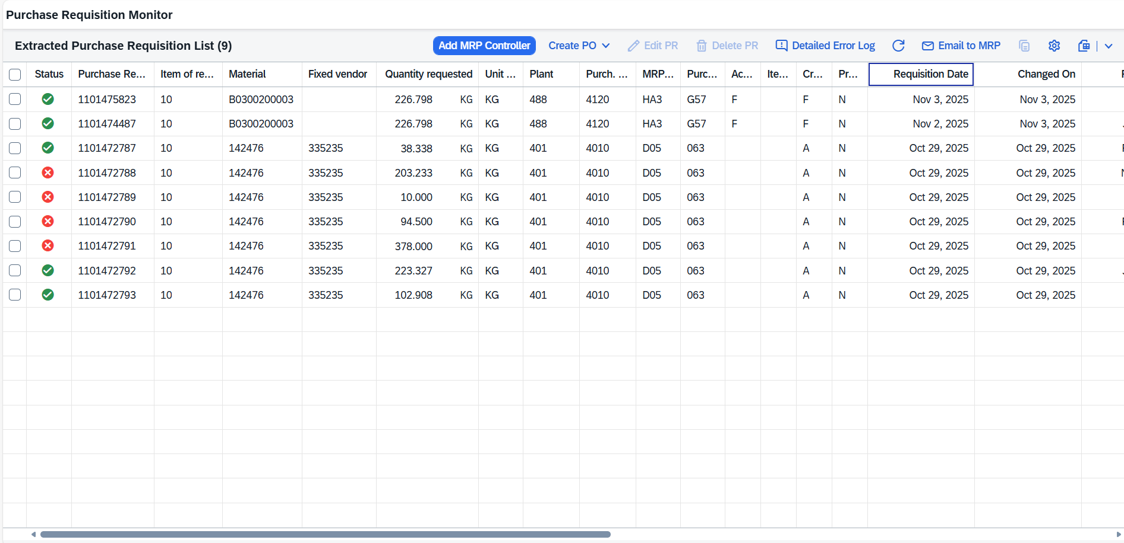

Below are the observations and required functions
HEADER - Top of the Screen
Total number of PR lines
No of Error Lines
No of PRs ready to convert
No of Deleted PRs
FILTER
Filter option for each column available in extract
Option to save multiple variants
Date filter range selection: option to select current date + or - no of days
Sum up total qty and Value for the selected PRs
Quantity, Value and Date Format
Few options to select no of PR lines per page from the extract - For ex: drop down option with 10/20/30/50
Auto alignment on column width based on field length
EDIT
F4 and Direct change option
Sperate option for Delete and undelete

Acronyms

IBP – Integrated Business Planning
PR – Purchase requisition
PO - Purchase order
NB – Standard Purchase requisition
ZG – Deployment STR(PR)

